Ast DDW Part Ordering Guide

1. Open Service Channel FTM App.
2. Create a linked WO assigned to the warehouse coordinator from the original repair work order by selecting **MORE** and then selecting **LINK WORK ORDER.**

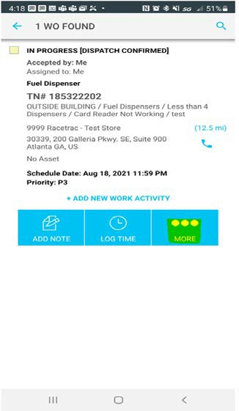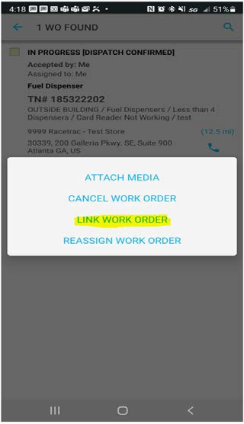

1. There are new drop-down path options for your part orders. Select your “Area” as “IHM USE ONLY”, “Problem Type” as “Part Order”, “Asset” as the equipment you are working on, and finally, in the “Problem” section select “Order parts”.

1. In the description field, you will enter in part #, quantity and Ast Truck#.

1. Ast assigns the local warehouse as the Service Provider.

1. Ast changes the original WorkOrder status to “Parts on order/ddw”.
2. Part will be sourced by warehouse and linked workorder will be updated with shipping status.
3. If the part is available from another Tech, a linked workorder will be created and assigned to a local Ast using the steps outlined below:

**Workorder:**

Location: Original Store with the Original Work Order

Provider: Racetrac FTM

Tech Assignee: Ast shipping out the part.

Trade Category: Projects

Description:

Please pack and ship (1) P1501010 to Ast 1346 Home store#. Prepackage label is attached to workorder.

Please drop off package to the closest UPS site or IHM warehouse.

*\*Please allow 48 hours for your inventory to be updated, once workorder has been placed in completed/confirmed.*

9. Coordinator will create a shipping label for Ast and attach it to the linked workorder.