**Ast Equipment Part Ordering Guide**

1. Open Service Channel FTM App.
2. A screenshot of a phone

   Description automatically generated with medium confidenceSelect command “**ADD NOTE”** from any open/in progress work order assigned to you.
3. Enter in the details of the parts and quantity needed. Please supply as much information as you can, for example: Part Name, Manufacturer #, Part Description.
4. Then Press “**Proceed”**

1. **A screenshot of a phone

   Description automatically generated with low confidence**Scroll Down to RT Equipment so they are added to the note. Click “**SEND”**
2. 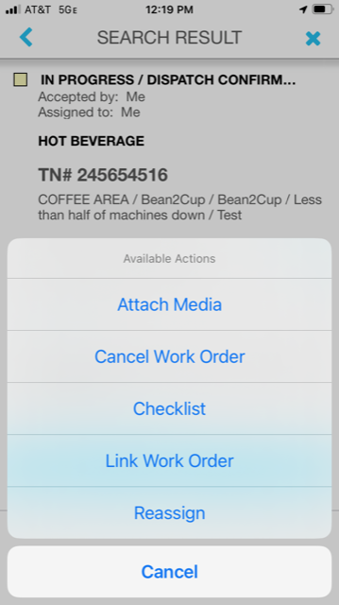A screenshot of a phone

   Description automatically generated with medium confidenceClick command “**MORE”** then select “**Attach Media”** to upload a photo of Model and Serial # of the piece of equipment you are working on.