**Training Guide: AST**

1. Complete and close out your repair ticket as normal
2. Issue parts used in the repair to the store on the Workday App
3. Take your warranty part and put it in the box that your replacement part came in. Label this box with the “Return to Vendor” sticker
   1. If you did not receive your part in a box place the sticker on the warranty part as best as you can
4. Open a new ticket in the service channel providers app using the drop-down path to navigate to the correct piece of equipment that you just repaired. There are new drop-down path options for your part returns. Select your “Area” as “IHM USE ONLY”, “Problem Type” as “Warranty”, “Asset” as the equipment you are working on, and finally, in the “Problem” section select the part that you are returning.

1. In the “Details” section, list out the Manufacturer Part Number, the GVR Number, Part Serial Number, Unit Serial Number, and Unit Model Number separated by parentheses: Part #:(M14330A001) Part Serial #:(987-340-102) Unit Serial #:(EN00170350) Unit Model #:(NL1) GVR #:(123456789)
   1. If you have multiple warranty parts to send back, create a ticket for each of them

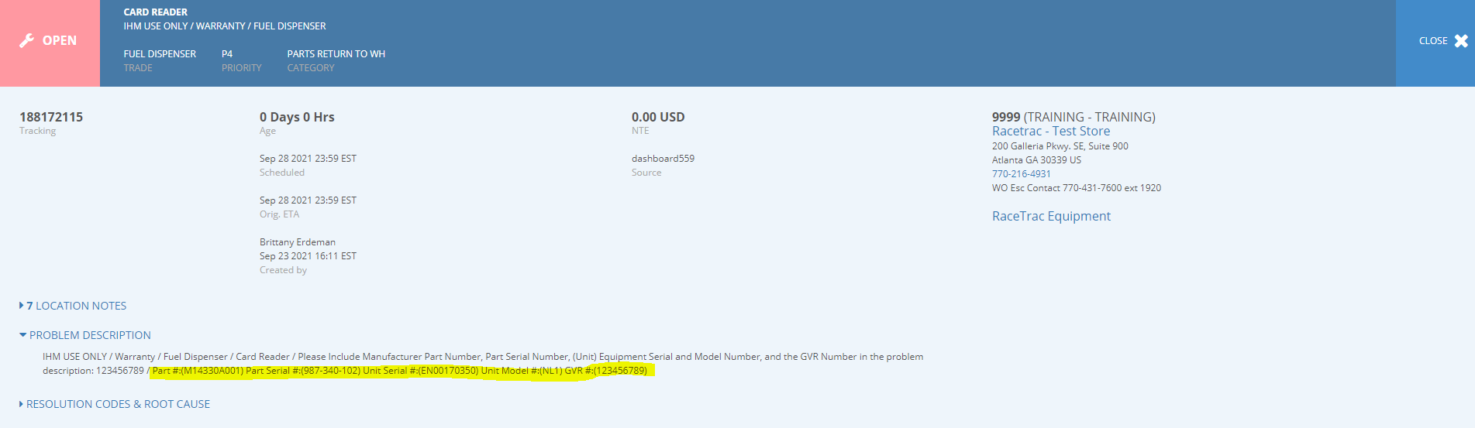

Part Number:(M14330A001)

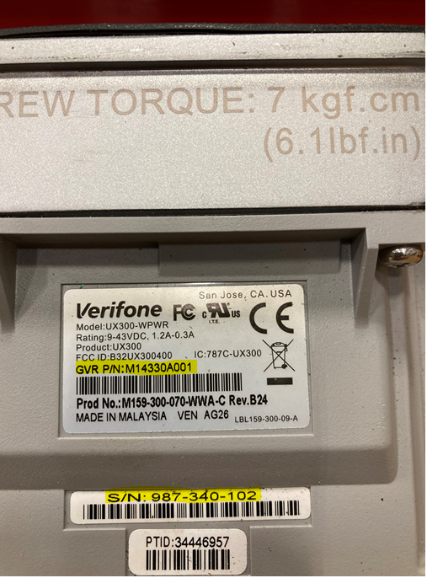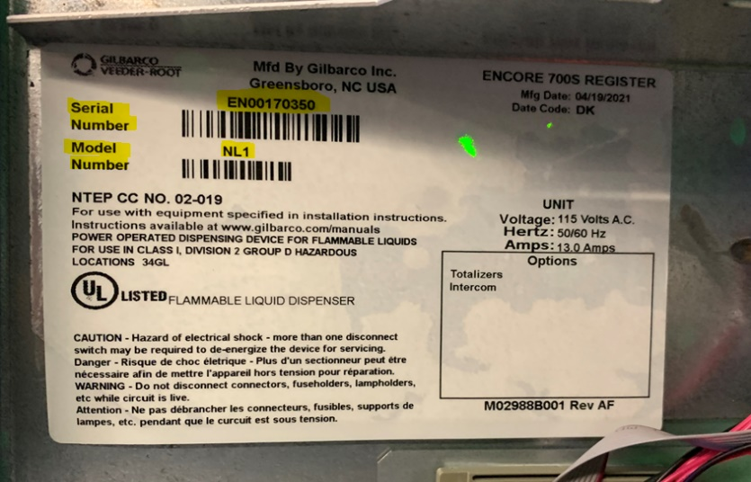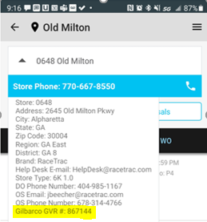

The GVR number is in the notes section in service channel for each store

The Unit Serial Number and the Unit Model Number are located inside the pump on the left-hand side.

The Part Number and Part Serial Number are located on the back of the part you remove from the equipment

GVR Number:(867144)

Part Serial Number:(987-340-102)

Unit Serial Number:(EN00170350)

Unit Model Number:(NL1)

1. After you have created a ticket, add a note that indicates the reason for return:
   1. Reason for return
      1. Unit under warranty (24 Months from installation)
         1. For “Unit Under Warranty” returns, that pertain to full dispensers under warranty including sites that received the FlexPayIV Kit
      2. Part under warranty (12 Months from installation)
         1. Parts-only warranty applies when the warranty expiration sticker on the part(s) is still valid, but the part was removed from a unit beyond the unit warranty. This will be dispensers that only received Omnia boards
      3. Warranty Recall
      4. Printer Return

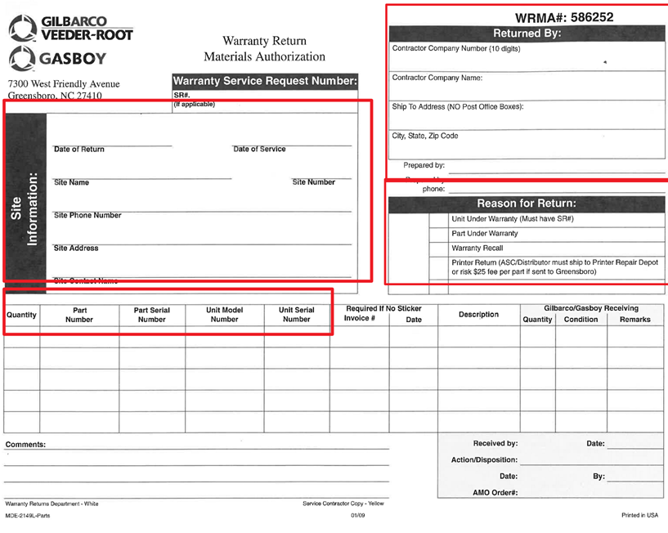

1. 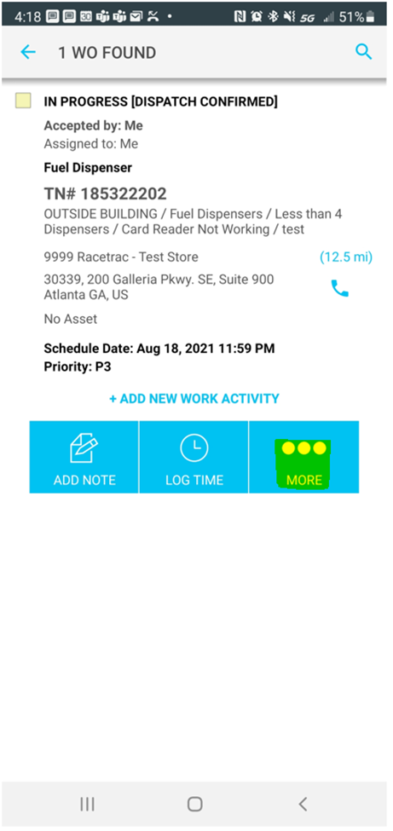Navigate to the ticket you just created on the app, change the category to “Warranty Part Return” and link the ticket to the original repair WO by clicking the “More” button, “Link Work Order” in the pop up, and selecting the WO you would like to link the ticket to.

1. Dispatch the ticket to your warehouse coordinator
2. The next time you return to your home store, put all of your warranty return parts to in your tote to send back to the warehouse

**User Guide – Warehouse**

1. Warranty Parts Return work order automatically dispatched to Warehouse Coordinator
2. WHC keeps it open until part has arrived from AST
3. WHC fills out WRMA form for each part--Uploads pic to WO
   1. Returned BY Section: RT ASC #**(001744150)**
   2. Site Information Section
   3. Part Information Section
   4. Reason for Return
4. WHC ships all parts back to Gilbarco once per week to appropriate address below:
   1. All Parts Except Printers and Cash Acceptors

Gilbarco Inc.

7300 W. Friendly Avenue Greensboro, NC 27410

Attn: Warranty Returned Goods

* 1. Printers and Cash Acceptors

Gilbarco Printer Repair

4750 Ashley Drive

Hamilton, OH 45011

